MongoDB Mini Guide and Exercises

Markus Veijola

Opiframe Oy

Installation

Download the MongoDB Windows installation package from here: https://www.mongodb.org/downloads
From the download page you can choose the wanted platform: Windows, Mac OS X, Linux or Solaris. This tutorial assumes that you are using windows platform.

After downloading, execute the .msi file and follow the instructions (you can just leave the default values during the installation).
After the MongoDB is installed create next folder structure in C: drive
C:\data\db
This is very important step, since MongoDB uses this path to store your collections (by default). If you try to start MongoDB without creating this folder structure, you end up to an error.

Starting MongoDB

MongoDB default installation path is
C:\Program Files\MongoDB\Server\3.0\bin
If you browse to the bin folder you can see mongod.exe file. This executable starts the MongoDB server. To start the MongoDB server open command line window and browse to bin folder. Write command mongod.exe in command window and press enter. You should see now that MongoDB server starts up and is running and listening port 27017.
If you want to stop the server just press Ctrl-C in command window.
That’s it. You have MongoDB now installed and running in your machine.

MongoDB Control Shell

MongoDB comes with JavaScript shell that allows you to run MongoDB commands and execute JavaScript writing them directly in this command line tool. Usually this tool is used for administrative work like inspecting the MongoDB instance or calling some built-in functions.

You can start the shell by opening command line in MongoDB bin folder. Then execute command mongo.exe and you have the Shell running (Note that the MongoDB server must have been started with command mongod.exe before doing this!)
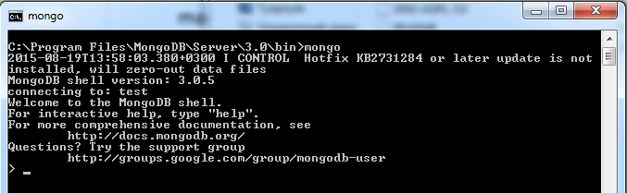
Shell is automatically connected to running MongoDB instance and connected to test database.
The Shell is fully-featured JavaScript interpreter, capable of running any arbitrary JavaScript programs:
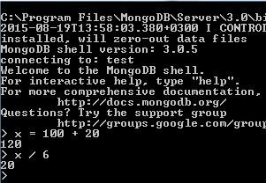

You can use also standard JavaScript libraries like Math:
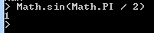

You can even define and call functions:
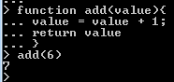

The most interesting part of the Shell is that is actually a standalone MongoDB client. This allows you to use MongoDB global variables, which again makes possible to do database actions in the Shell. For example you can do all the CRUD (create,read,update,delete) operations in database using the shell and much more.
The shell automatically connect to test database when started. You can now use global variable db to do some database actions. Just write the command db in shell and you see which database is assigned (in our case it is the test):
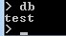

Normally if you want to make some complex administrative scripts you probably want to put that script in to the file and execute it. To execute a JavaScript file containing your maintenance code just run the command load(“js_file.js”);
NOTE! Build in commands like use <dbname>, show dbs etc, WILL NOT work from script file! Only Mongo Shell Script API functions will work. See more from here Mongo Shell Script API

The Shell contains also some add-ons that are not valid JavaScript syntax. Here are few you can test:
help shows help
db.help() Show help for database methods.
show dbs lists all databases in this MongoDB instance
use <db_name> changes the current database i.e. use foobar will change to foobar database
show collections Print a list of all collections for current database
show users Print a list of users for current database.

Basic Operations with the Shell

In this section you will see how to make basic database operations a.k.a CRUD (create,read,update,delete), within mongo Shell. Also you will see how to make basic queries, drop the database if needed, and some other useful commands.
First we need to “create” a database. You can do it with next command use <dbname>. If the database with given name don’t exits, mongo will create you one. Note if you now write command show dbs, you will not see the created database. Database is actually created when you insert the first collection in it.
Tip: If you want to create a database from script file, it’s done with next command…
db = connect("localhost:27017/<dbname>");

Creating collections and inserting documents

Next you need to create a collection to created database. This is done by using the global variable db.
To create a collection you just give a name for it, and pass some JSON object containing your document data. My idea is to create a database containing friends address information. The collection name will be friends, and it contains next fields:
{
name:String
age:Number,
address:String
}

No we add the collection with ONE document in it with next command:
db.friends.insert({name:”Markus Veijola”,age:”39”,address:”Rautatienkatu 40”});
Now you can enter command show collections to see that the friends collection was added to your database.
If you want to create a collection from script file you can do it with following commands:
db = connect("localhost:27017/people");
//Create people collection
db.createCollection("people");
//Add document to people collection
db.people.insert({country:"Suomi",gender:"Male"});

Read the document from collection

One of the most common operations is to read data from collections. This can be done with find() function. There are many kind of queries you can make to collections. Next snippets shows the most common ones…
Next line will fetch ALL the documents from friends’ collections:

db.friends.find(); //Returns an array of document objects

Here are some query examples:
//Find all documents where name is Markus
db.friends.find({name:”Markus”});
//Find all documents where name is Markus or Jussi
db.friends.find( { name: { $in: [ 'Markus', 'Jussi' ] } } );
//And condition, find all documents where name is markus
//and age is LESSER THAN 40
db.friends.find( { name: 'markus', age: { $lt: 40 } } )
//And and Or compined. Find all documents where name is //markus or age is lesser than 40 or greater than 30
db.friends.find( {name:”markus”,$or[{age:{$gt:30},age:{$lt:40}]});

For more examples of queries see http://docs.mongodb.org/manual/tutorial/query-documents/

Update document

You can update a document using update() function. Update function takes three arguments: query, update data and options.
For example if I want to update age from a person whose name is Andy, I could do it with following line: db.friends.update({name:”andy”},{age:30});
For more about update see http://docs.mongodb.org/manual/reference/method/db.collection.update/

Delete document

To delete or remove documents from collections one uses remove() method. You can remove all the documents from collections, or use some query parameters to tell a specific document(s) to be removed. Here are few examples:
//Remove all documents from friends collections
db.friends.remove();
//Remove all documents from friends collections where age is
//greater than 20
db.friends.remove({age:{$gt:20}});

NOTE! When you query documents you can use pretty() function to get more clear output of database i.e. db.friends.find().pretty();

Drop database

To remove whole database you can use dropDatabase() function. REMEMBER to switch to correct database before calling this function. For example removing database “my_database”:
use my_database
db.dropDatabase();

Testing performance and indexing documents

If the database we created, will contain millions of documents we have to face the fact, that the performance is one of our concerns.
Mongo contains some useful methods for testing performance i.e. how long query takes when we have like 1,5 million documents in our collection. The function is explain().
Usually when testing with lots of data, you just fill the database with some dummy data using i.e. loop statements…
//Create 1000000 documents in friends collection
for(i=0; i < 1000000; i++){
db.friends.insert({name:”name” + i,age:i, address:”test”});
}

Now we can test querying the big database. Let’s say we want to get the information about friend whose name is name 452 and see the result how long the query takes…
db.friends.find({name:”test452”}).explain(“executionStats”);
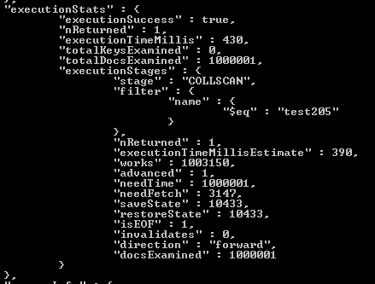

We can see that the query takes 430ms, which is pretty bad, if you think that there are like 1000 simultaneous queries from clients going on.

Question is how we can fix this better? The answer is indexing our data in database. Index is like a key, which we can use when querying database. You can define which key in your database will act as an index. For example we had keys: name, age and address. Selecting the correct key is not an easy task. You should think what key will be used in MOST queries made in database. If you find one, that’s your index. Let’s say that we have make some investigation about queries and the name key in our document is the one which is present in most of ones. So let’s make it as an key in our document:
db.friends.createIndex({name:1},{unique:true});

Now if you run the command db.friends.find({name:”test452”}).explain(“executionStats”), you should see that the query time is much lower (in my case it was reduced from 430ms -> 85ms).

Exercises
Create a database with name students.
Create a collection that contains next kind of documents. The collection will be like tables in picture below:
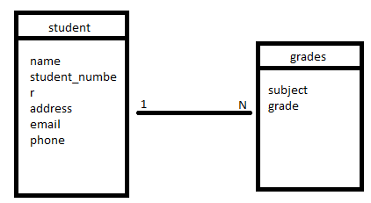

{
name:String,
student_number:Number,
address:String,
email:String,
phone:String,
grades:[{subject:String,grade:Number}]
}

Insert 20 student documents in your collection, with different values.
Make next kind of queries to database:
- Get all students
- Get all students with some specific name
- Get all student that student number is greater than 6
- Get all students that name is i.e. “Jack” and the student number is between 5 and 10
- Get all students that have a grade i.e. 3 in Maths (see help from querying embedded documents from http://docs.mongodb.org/manual/tutorial/query-documents/)
- Create some dummy data say 100 000 students. Make some queries with explain() function. Check the query time. Make a query with student_number. Check the query time…
- The development team has made the needed queries for our database. It seems that student_number is the one that appears in most of them. Make student_number as primary index in your collection. Run some queries with student number in it. Check the query times…is it now lower? Make some query without student_number. What can you now say about query time?
- Drop the database
- Make a script file that creates the database, collection and adds some documents in it. Run the script and see that all things are in place.
MongoDB vs MySQL
